##### AI-Driven Personalized Content Recommendation System for E-Commerce Web Applications

##### A PROJECT REPORT

###### ***Submitted by***

##### Mohammad Vaish Adnan Sheikh

***in partial fulfillment for the award of the degree***

***of***

##### Master of Computer Application



INTEGRAL UNIVERSITY LUCKNOW

MAY 2025



**CERTIFICATE**

Certified that this project report **“AI-Driven Personalized Content Recommendation System for E-Commerce Web Applications”** is the bonafide work of “**Mohammad Vaish and Adnan Sheikh”** who carried out the project work under my supervision.

**Dr. Muhammad Kalamuddin Ahmad**

**Associate Professor**

Department of Computer Application

Integral University, Lucknow



**CERTIFICATE**

Certified that this project report **“AI-Driven Personalized Content Recommendation System for E-Commerce Web Applications”** is the bonafide work of “**Mohammad Vaish and Adnan Sheikh”** who have successfully carried out the project.

**Dr. Md. Faizan Farooqui**  **Dr. Mohd. Faisal**

Project Coordinator Head Department of Computer Application Department of Computer Application

Integral University, Lucknow Integral University, Lucknow

**DECLARATION**

“I hereby declare that this submission is my own work and that, to the best of my knowledge and belief, it contains no material previously published or written by another person nor material which has been accepted for the award of any other degree or diploma of the university or other institute of higher learning, except where due acknowledgment has been made in the text”.

Date:

Mohammad Vaish

Adnan Sheikh

**Acknowledgement**

We, the team members of this project, would like to express our sincere gratitude to all those who have supported and guided us throughout the development and completion of this project. We would like to extend our heartfelt thanks to our project guide, Dr. Muhammad Kalamuddin Ahmad, for their continuous guidance, insightful suggestions, and invaluable support. Their expertise and encouragement were crucial to the successful execution of this project. Our sincere appreciation goes to the project coordinator, Dr. Md. Faizan Farooqui, and the Head of the Department, Dr. Mohd. Faisal, for their continuous support and for providing the necessary resources and infrastructure required to carry out this work. We are grateful to all the faculty members of the Department of Computer Application for their constructive feedback and encouragement during the course of the project, which greatly contributed to its success. We would also like to thank our families and friends for their unwavering support and understanding during this challenging period, as well as for their patience and encouragement. Lastly, we acknowledge and appreciate the contributions of the various authors and researchers whose work we referenced throughout this project. Their research provided us with valuable insights and a solid foundation for our work.

Thank you to everyone who has played a part in the successful completion of this project.

TABLE OF CONTENTS

|  |  |  |
| --- | --- | --- |
|  |  |  |
|  | **CERTIFICATE** | i |
|  | **CERTIFICATE** | ii |
|  | **DECLARATION** | iii |
|  | **ACKNOWLEDGEMENT** | iv |
|  | **LIST OF FIGURES** | viii |
|  | **ABSTRACT** | ix |
|  |  |  |
| **CHAPTER NO.** | **TITLE** | **PAGE NO.** |
| 1. | **INTRODUCTION** | 1-5 |
| 2. | **PROBLEM IDENTIFICATION AND FEASIBILITY STUDY**  2.1. Problem Identification  2.2 Feasibility Study  2.2.1. Technical Feasibility  2.2.2. Economic Feasibility  2.2.3. Operational Feasibility  2.2.4. Legal and Ethical Feasibility  2.2.5. Market Feasibility | 6-14  6  7  7  9  11  12  13 |
| 3. | **REQUIREMENT ANALYSIS**  3.1. Functional Requirements  3.1.1. User Authentication and Registration  3.1.2. Product Management  3.1.3. Personalized Recommendations  3.1.4. Cart and Order Management  3.1.5. Order History  3.1.6. Admin Dashboard  3.2. Non-Functional Requirements  3.3. System Requirements  3.3.1. Hardware Requirements  3.3.2. Software Requirements  3.4. Data Requirements  3.5. Technology Used  3.5.1. React.js  3.5.2. Tailwind CSS  3.5.3. Node.js & Express.js  3.5.4. MongoDB  3.5.5. JWT (Json Web Token)  3.5.6. Flask | 15-29  17  17  17  18  18  19  19  19  22  23  23  23  24  24  25  26  27  28  28 |
| 4. | **REVIEW OF PREVIOUS WORK** | 30-42 |
| 5. | **PROJECT DESCRIPTION**  5.1. Project Overview  5.2. Objective & Scope  5.2.1. Objective  5.2.2. Scope  5.3. Technologies Used  5.3.1. Frontend  5.3.2. Backend  5.3.3. Database  5.3.4. Machine Learning  5.3.5. Tools & DevOps  5.4. Project Workflow  5.4.1. User Authentication and Access Control  5.4.2. Product and Cart Management  5.4.3. Order Management  5.4.4. Admin Dashboard  5.4.5. AI-Driven Personalized Recommendations  5.5. Detailed Features  5.5.1. Personalized Recommendations  5.5.2. Cart Management  5.5.3. Admin Panel  5.5.4. Responsive UI  5.5.5. Reports and Analytics | 43-49  43  44  44  45  45  45  46  46  46  47  47  47  48  48  48  48  49  49  49  49  49  49 |
| 6. | **DESIGN**  6.1. Data Flow Diagram  6.2. Activity Diagram  6.3. Class Diagram  6.4. Snapshots of the project | 50-71  50  53  55  57 |
| 7. | **CONCLUSION AND FUTURE WORK** | 72-77 |
|  |  |  |
|  | **REFERENCES** | 78 |
|  | **TEAM DETAILS** | 79-80 |

LIST OF FIGURES

|  |  |  |
| --- | --- | --- |
| **FIGURE NUMBER** | **FIGURE NAME** | **PAGE NUMBER** |
| 3.1. | Gantt Chart | 16 |
| 6.1. | Data Flow Diagram (DFD) | 52 |
| 6.2. | Activity Diagram | 54 |
| 6.3. | Class Diagram | 56 |
| 6,4. | Homepage | 59 |
| 6.5 | Signup Page | 60 |
| 6.6 | Login Page | 61 |
| 6.7 | Profile Page: Admin | 62 |
| 6.8 | Admin Dashboard | 63 |
| 6.9 | Add Product Page | 64 |
| 6.10 | Update Product Page | 65 |
| 6.11 | Product Purchasers | 66 |
| 6.12 | Profile Page: User | 67 |
| 6.13 | Products Section | 68 |
| 6.14 | Cart | 69 |
| 6.15 | AI-Driven Recommendations | 70 |
| 6.16 | Order History | 71 |

**ABSTRACT**

This thesis presents the development of an AI-Driven Personalized Content Recommendation System for E-Commerce Web Applications, aimed at enhancing user experience through personalized product suggestions. Leveraging the MERN stack (MongoDB, Express, React, Node.js), Flask, and Tailwind CSS for the frontend and backend, the system integrates machine learning algorithms to provide real-time, relevant product recommendations. The application features secure user and admin login/signup, user profile management, and an interactive product section where customers can browse and purchase items. A key functionality is the Cart, where the AI-powered recommendation engine analyzes user choices and offers personalized suggestions upon clicking the "Get Recommendation" button. The system also includes an Order History page, allowing users to view past purchases, while the Admin Dashboard empowers administrators with CRUD (Create, Read, Update, Delete) operations to manage products and monitor customer interactions. Machine learning tools such as pandas, mlxtend, and joblib are utilized to process data and build recommendation models, ensuring high-quality suggestions based on individual user preferences. This project aims to optimize the online shopping experience by providing a tailored approach to product discovery, increasing user engagement, and driving sales in e-commerce environments.

**CHAPTER 1.**

**INTRODUCTION**

E-commerce has rapidly transformed from a niche market into a cornerstone of global retail, revolutionizing the way consumers shop. The benefits of e-commerce are manifold, offering unparalleled convenience, a vast product selection, and the ability to shop at any time from anywhere. However, as the e-commerce industry continues to grow, it faces several key challenges that hinder the optimal user experience and business profitability. Two primary issues that consistently emerge in the e-commerce domain are information overload and customer retention. The sheer abundance of available products on modern e-commerce platforms can overwhelm consumers, making it increasingly difficult to sift through the options to find what is truly relevant to their individual preferences and needs. As a result, customers often struggle to make purchasing decisions, leading to frustration and a poor shopping experience. This can significantly impact business outcomes, including conversion rates and overall user satisfaction.

Moreover, in an age of increasingly competitive digital marketplaces, retaining customers has become another significant challenge. Customer loyalty is hard to maintain when consumers have a wide variety of shopping options and are often enticed by discounts or new offers from competitors. Personalized shopping experiences are crucial in fostering long-term customer loyalty, as they provide users with tailored experiences that feel relevant and engaging. The lack of personalization can lead to a disconnected, one-size-fits-all experience that fails to resonate with individual shoppers. As a result, e-commerce platforms must find innovative ways to not only attract customers but also keep them engaged, ensuring they return for future purchases.

To mitigate these challenges, AI-driven personalization has emerged as a transformative tool for the e-commerce industry. The concept of personalization in e-commerce involves analyzing user data, such as browsing history, purchase patterns, and behavioral interactions, to predict and present products that match individual preferences. Machine learning algorithms can identify trends and make highly accurate product recommendations, creating a shopping experience that is tailored to each user. This personalization fosters higher user satisfaction by reducing decision fatigue and increasing the likelihood of product discovery, which ultimately drives conversions and sales. Personalized recommendations also enable businesses to enhance customer retention by maintaining engagement over time and encouraging repeat purchases based on evolving user preferences.

However, integrating AI into e-commerce platforms comes with several challenges. One of the most significant hurdles is selecting the appropriate machine learning models that can accurately predict customer preferences in real-time. Furthermore, handling and processing large volumes of customer data in a manner that is both efficient and effective is another key concern. Machine learning models require vast amounts of data to function accurately, and managing these datasets can become complex as the system scales. Another challenge is the need for real-time recommendation delivery. For an e-commerce platform to remain responsive and engaging, the recommendation system must provide personalized suggestions instantaneously, without compromising the platform’s performance. This can be especially challenging when dealing with high traffic loads or complex algorithms.

In light of these challenges, this thesis focuses on the development of an AI-Driven Personalized Content Recommendation System for e-commerce web applications, designed to offer a seamless, dynamic, and highly personalized shopping experience. The system is built using the MERN stack (MongoDB, Express, React, Node.js), which provides a robust and scalable framework for handling the front-end and back-end requirements of modern web applications. Tailwind CSS is utilized for styling, ensuring a responsive and user-friendly design. Flask is used for backend processes and facilitating the integration of machine learning algorithms into the application’s workflow. The combination of these technologies ensures that the platform remains scalable, secure, and efficient as it handles increasing amounts of user data and product inventory.

A key feature of the system is its ability to provide personalized product recommendations directly within the Cart section. Once a user adds an item to their cart, the AI-powered recommendation engine analyzes their previous interactions and selects related products that are most likely to appeal to their tastes. This feature helps users discover relevant products without the need to manually browse through an overwhelming number of options. By displaying only the most relevant items, the system enhances the user experience, reduces decision fatigue, and ultimately drives conversions. This recommendation process is made possible through the use of machine learning libraries such as pandas for data manipulation, mlxtend for building recommendation models, and joblib for model serialization and deployment. These tools work in tandem to ensure that the recommendation engine is both effective and scalable.

Additionally, the system includes an Admin Dashboard that enables administrators to efficiently manage products and track user behavior. The dashboard provides comprehensive features for performing CRUD (Create, Read, Update, Delete) operations on products, ensuring that the inventory is always up to date. Administrators can also gain insights into which products are being purchased and which users are most engaged with the platform, enabling data-driven decision-making for product management and marketing strategies. This administrative control helps businesses optimize their product offerings and better understand customer preferences, further enhancing the platform’s ability to cater to user needs.

The project is designed to evolve with user interactions. The recommendation system improves over time by continuously learning from customer behavior, leading to increasingly accurate predictions and a more personalized shopping experience. This iterative learning process is a key feature of machine learning, where models are refined based on real-time data. However, as the system scales, the challenges related to system performance, data privacy, and security also become more prominent. Handling large volumes of sensitive customer data while maintaining strict privacy standards is crucial for building user trust and ensuring compliance with data protection regulations. As such, the project also emphasizes the importance of secure data storage, encryption, and responsible data management practices.

In conclusion, this project aims to create an AI-powered e-commerce platform that addresses the challenges of information overload and customer retention by delivering personalized product recommendations. By integrating machine learning into the shopping experience, the platform not only enhances the customer journey but also provides businesses with the tools they need to drive engagement, boost sales, and stay competitive in the fast-evolving e-commerce market. The system’s ability to process large datasets, deliver real-time recommendations, and continuously learn from user behavior positions it as a valuable tool for both businesses and consumers, promising a more engaging and rewarding online shopping experience.

**CHAPTER 2.**

**PROBLEM IDENTIFICATION AND FEASIBILITY STUDY**

**2.1. Problem Identification**

The rapid growth of e-commerce has significantly transformed the way consumers shop, but this growth has also given rise to several challenges. As the number of online shoppers increases and product catalogs expand, e-commerce platforms face problems in delivering personalized experiences.

One of the most pressing issues in e-commerce is information overload. With thousands or even millions of products available for purchase, consumers are often overwhelmed by the sheer volume of choices. This overload not only makes the shopping experience frustrating but also leads to decision fatigue, where users are unable to find what they want or make quick decisions, resulting in cart abandonment and decreased conversion rates. Studies have shown that users are more likely to engage with platforms that provide personalized content tailored to their tastes and preferences.

In addition, customer retention has become a growing challenge in the e-commerce industry. The ease of switching between online stores and the constant presence of promotions, discounts, and new products from competitors means that retaining customers is increasingly difficult. E-commerce businesses are constantly seeking ways to improve their ability to keep customers engaged and returning to their platforms. However, without personalized recommendations or a tailored shopping experience, customers may not feel a strong connection to a platform and may choose alternatives.

Furthermore, traditional recommendation systems, which often rely on basic filtering techniques, fail to provide accurate, relevant suggestions. Personalization is crucial to improving user experience, as users expect e-commerce platforms to understand their preferences and deliver content and products that suit their tastes. However, integrating AI-powered personalization into e-commerce systems comes with its own set of challenges, such as technical complexity, data privacy concerns, and real-time processing requirements.

These problems collectively point to the need for a more structured, automated, and efficient approach to inventory management. This is where the proposed AI-Driven E-Commerce Platform can help, addressing these challenges with modern solutions that improve accuracy, efficiency, and scalability.

**2.2. Feasibility Study**

Before embarking on the development of an AI-driven personalized content recommendation system for e-commerce applications, it is essential to evaluate the feasibility of such a project. A thorough feasibility study addresses multiple dimensions that can affect the success of the system, including technical, economic, operational, legal, ethical, and market factors.

**2.2.1 Technical Feasibility**

The technical feasibility of the project revolves around assessing whether the proposed technology stack can handle the complexity of developing and implementing an AI-powered recommendation system within an e-commerce platform. This includes evaluating the system architecture, integration capabilities, performance, and scalability.

The chosen MERN stack (MongoDB, Express, React, Node.js) provides a solid foundation for building scalable and maintainable applications. MongoDB, as a NoSQL database, is suitable for the flexible and unstructured data typical in e-commerce systems—such as product details, customer interactions, and real-time browsing behavior. React, on the other hand, offers a highly responsive and interactive user interface that can handle dynamic content generation, which is critical when delivering personalized recommendations. Node.js and Express serve as the backend infrastructure, which can handle multiple concurrent user requests efficiently.

From a machine learning standpoint, Flask serves as an ideal framework for integrating the recommendation system into the backend. Flask is lightweight, flexible, and provides robust support for integrating machine learning models into web applications via RESTful APIs. For model training, the use of pandas ensures efficient data manipulation and processing, while mlxtend is employed for implementing advanced machine learning algorithms, particularly those focused on recommendation strategies. The joblib library is utilized to serialize and deploy models for real-time inference, ensuring that recommendations are delivered instantly to users.

The real-time nature of the recommendation engine poses a significant technical challenge. Users expect immediate feedback when interacting with the platform, especially when selecting products in the cart and requesting personalized recommendations. This requires efficient data handling, real-time data processing, and the ability to scale the backend infrastructure to support large volumes of concurrent requests. Cloud-based services or high-performance on-premises servers are essential to support the computational needs of AI model training and inference. Auto-scaling solutions will ensure that the platform can dynamically adjust its resource usage based on demand.

The integration of machine learning models and real-time data processing also requires robust data pipelines. For the system to generate accurate and timely recommendations, data about user actions, browsing history, and purchase patterns must be collected, processed, and fed into the recommendation algorithms continuously. Batch processing and streaming data architectures need to be carefully designed to balance performance and data consistency, especially as the system grows.

Lastly, the overall system architecture must ensure high availability and low latency. For instance, content delivery networks (CDNs) can be employed to improve the load times of product pages and recommendations, especially for users in geographically diverse regions.

**2.2.2 Economic Feasibility**

Economic feasibility assesses the costs involved in developing and deploying the AI-driven recommendation system against the expected benefits in terms of revenue generation, cost savings, and return on investment (ROI).

The initial investment for the project includes costs associated with research and development, technology acquisition, software development, data collection, and the infrastructure required to run machine learning models. While the MERN stack and Flask are open-source technologies, which help reduce initial development costs, other expenses include the hiring of skilled personnel such as data scientists, developers, UX/UI designers, and system administrators. These professionals will be responsible for developing, testing, deploying, and maintaining the system. Additionally, cloud service providers, such as AWS, Azure, or Google Cloud, will incur operational costs to host and scale the platform, particularly as the platform collects and processes large amounts of user data.

On the operational side, there will be ongoing costs related to maintaining the system, including server hosting fees, API usage costs (if third-party services are integrated), and subscription fees for any premium tools or libraries used for machine learning model training or data processing. Regular updates and bug fixes will also incur costs, as will security measures to protect sensitive customer data.

Despite the initial and ongoing costs, the economic benefits of implementing an AI-driven personalized recommendation system are significant. First, personalized recommendations have been shown to drive higher conversion rates, as users are more likely to purchase products that align with their tastes and preferences. A personalized shopping experience can increase customer satisfaction, which leads to higher customer retention rates. Given that acquiring new customers is more expensive than retaining existing ones, this increased retention can result in more frequent repeat purchases, improving long-term profitability.

Moreover, personalized recommendations provide valuable insights into customer behavior, allowing businesses to make data-driven decisions about inventory management, product offerings, and marketing strategies. By analyzing patterns in user data, businesses can identify trends, predict demand, and optimize their product catalog, reducing the risk of overstocking or understocking items.

The ROI for the project can be substantial, especially considering that personalized recommendations can significantly boost revenue and customer lifetime value (CLV). If implemented correctly, the system can quickly pay for itself by improving sales performance and customer engagement.

**2.2.3 Operational Feasibility**

Operational feasibility examines whether the proposed system can be integrated smoothly into the existing operational structure of the e-commerce platform. This involves assessing how the AI recommendation engine can work alongside existing systems for inventory management, order processing, and customer relationship management (CRM).

One critical factor in operational feasibility is the seamless integration of the recommendation system with the user interface (UI). The system must be easy for customers to interact with, ensuring that product recommendations are presented in an intuitive, non-intrusive manner. For instance, the "Get Recommendation" button in the cart should be easy to find and use, and the recommended products should appear in a way that feels natural and relevant to the user’s shopping behavior. Ensuring that the recommendation engine delivers accurate and timely suggestions is essential for maintaining a positive user experience.

From an administrative perspective, the system must allow the management of products, tracking of inventory, and monitoring of user behavior. Administrators should have access to real-time analytics to assess how well the recommendation engine is performing, which products are being recommended most frequently, and how users are interacting with the system. The Admin Dashboard should provide detailed metrics on customer interactions, allowing for further optimization of the system.

Another key consideration for operational feasibility is the data pipeline. The AI recommendation engine needs to continuously update its understanding of user preferences by collecting and analyzing interaction data in real-time. This requires robust backend processes to handle large amounts of data, and administrators must be able to monitor and manage the flow of data from the user interface to the machine learning models.

Lastly, the system must remain scalable to handle future growth. As the e-commerce platform attracts more users, the recommendation system must be capable of processing increasing volumes of data and delivering recommendations without performance degradation. Cloud infrastructure with auto-scaling capabilities is essential to ensure that the system can handle traffic spikes during peak shopping periods, such as holidays or sales events.

**2.2.4 Legal and Ethical Feasibility**

Legal and ethical feasibility is paramount, especially when dealing with sensitive user data. The recommendation system relies on data collection to generate personalized suggestions, and this data must be handled in compliance with global data privacy regulations. General Data Protection Regulation (GDPR) in the European Union, California Consumer Privacy Act (CCPA) in the United States, and other similar laws impose strict requirements on how companies can collect, store, and process user data.

The system must include mechanisms for user consent, ensuring that customers are fully informed about what data is being collected and how it will be used. Clear and transparent privacy policies should be in place to provide users with a better understanding of their rights. Users should also have the ability to manage their preferences, access their data, and request deletion if desired. Failure to comply with these regulations could result in substantial fines, damage to brand reputation, and loss of customer trust.

Ethically, the system must be designed to avoid algorithmic bias. If the recommendation engine is not properly trained or is based on flawed data, it could lead to biased or irrelevant suggestions. For example, if the algorithm favors products from certain brands or categories due to skewed training data, this could alienate users and reduce their trust in the platform. To mitigate this risk, the recommendation models must be regularly evaluated and updated to ensure that they provide fair and accurate suggestions.

Another ethical issue is ensuring that user data is anonymized and not exploited for purposes other than improving the shopping experience. Data security measures must be in place to prevent breaches and unauthorized access to personal information.

**2.2.5 Market Feasibility**

Market feasibility evaluates the likelihood of success for the AI-driven recommendation system within the current market environment. The demand for personalized shopping experiences is rapidly growing, and e-commerce platforms are increasingly turning to AI and machine learning to gain a competitive edge. Personalized product recommendations have proven to increase conversion rates, average order value, and customer retention—key metrics that drive business success in e-commerce.

The adoption of AI-powered recommendation systems is becoming more common, with many e-commerce giants already utilizing sophisticated algorithms to enhance the customer shopping experience. However, there is still considerable market potential for such solutions, particularly among small-to-medium-sized businesses (SMBs) that may not yet have the resources to develop AI-driven personalization in-house. This represents an opportunity to provide a valuable service to businesses that seek to differentiate themselves from larger competitors.

In addition, the cost-effectiveness of implementing the system is improving, as cloud-based infrastructure and machine learning services become more affordable. The scalability of AI-driven recommendation systems also makes them accessible to a wide range of businesses, from startups to large enterprises. The ability to provide actionable insights and real-time recommendations gives businesses a tangible way to enhance customer engagement, optimize product offerings, and improve their bottom line.

Given the growing importance of customer experience in e-commerce, the market feasibility of an AI-driven personalized recommendation system is high, with a broad range of potential clients across industries seeking to stay competitive in an increasingly personalized world.

**CHAPTER 3.**

**REQUIREMENT ANALYSIS**

The Requirement Analysis phase is a fundamental stage in the software development lifecycle. It involves identifying and defining the functional and non-functional requirements for the system, ensuring that the application will meet the needs of its users. In this section, we analyze the requirements for the AI-Driven E-Commerce project, focusing on the core features, technical specifications, and system requirements. The goal is to create a clear roadmap for designing, developing, and deploying a robust, scalable, and user-friendly application. The overview can be seen in **Figure 3.1**.



**Figure 3.1.** Gantt Chart

**3.1. Functional Requirements**

Functional requirements outline the specific features and capabilities that the system must offer in order to meet the user needs and solve the business problem effectively. These functionalities are grouped based on the various modules of the system. The main functional requirements for the AI-driven personalized content recommendation system are as follows:

**3.1.1. User Authentication and Registration**

The system must provide secure authentication and registration processes for different user roles. There will be two primary user roles:

**Admin:** Full access to the backend, product management, and analytics.

**Customer:** Access to the front-end interface, including product browsing, cart management, and personalized recommendations.

Features include:

Secure user sign-up and login.

Email verification for account activation.

Password recovery options.

Role-based access control for different user privileges.

**3.1.2. Product Management**

Admin users will need the ability to manage products in the catalog. The product management module should support:

**Adding, Updating, and Deleting Products:** Admins should be able to easily add new products, update existing details, and remove out-of-stock items.

**Product Categorization:** Products must be categorized by type, price range, or brand for better organization.

**Stock Management:** Admins will be able to update the product’s stock quantity to reflect real-time inventory data.

**3.1.3. Personalized Recommendations**

This is the core functionality of the system:

**Recommendation Generation:** Based on user behavior (browsing, cart additions, and previous purchases), the system will suggest relevant products to the user. These recommendations will be powered by machine learning algorithms.

**Get Recommendation Button:** When a customer is viewing items in their cart, they can click on the "Get Recommendation" button to receive personalized suggestions.

**Collaborative Filtering and Content-Based Filtering:** The system will use both these techniques for generating recommendations, enhancing the overall user experience.

**3.1.4. Cart and Order Management**

The system will have a cart module that enables users to:

**Add and Remove Products:** Users can add products to their cart and remove them when desired.

**View Cart Summary:** Display a list of products in the cart along with their quantities and total price.

**Order Confirmation and Checkout:** Once satisfied, the customer can proceed to confirm and place the order, selecting a payment method.

**3.1.5. Order History**

Users must be able to track their past purchases. Features include:

**Viewing Past Orders:** Customers can access detailed information about their previous orders, including dates, product details, and statuses.

**Reordering:** A functionality that allows users to easily reorder previous items from their order history with just a click.

**3.1.6. Admin Dashboard**

The system will provide an admin dashboard to manage the platform’s operations:

**Product Management:** Admins can view, add, update, or delete products from the catalog.

**Customer Insights:** Admins can see detailed reports on customer behavior, including the products most frequently viewed or purchased.

**CRUD Operations on Recommendations:** Admins will be able to adjust the recommendation model’s parameters and control the overall system's recommendation logic.

**3.2. Non-Functional Requirements**

Non-functional requirements define the overarching attributes of the system that ensure quality, performance, reliability, and user satisfaction. These characteristics play a key role in determining how well the system will perform under various conditions and how it meets the needs of its users. Below are key non-functional requirements for the AI-Driven Personalized Content Recommendation System for e-commerce applications:

**Response Time:** The recommendation engine must generate personalized product suggestions within 2-3 seconds after the user clicks the "Get Recommendation" button to ensure a smooth user experience.

**System Load Handling:** The platform should be capable of handling a high volume of concurrent users, especially during high-traffic events like sales seasons or promotional events, ensuring that the system does not experience performance degradation.

**Transaction Processing Time:** The checkout process, including payment gateway communication and order confirmation, must not exceed 5 seconds to prevent user frustration and cart abandonment.

**Horizontal Scaling:** The system architecture must allow horizontal scaling, enabling the addition of more servers or cloud-based resources to handle increasing traffic, especially during peak periods such as holidays or flash sales.

**Elastic Machine Learning Model Scaling:** The recommendation engine should be designed to handle the scaling of models as the number of products and user interactions grows, ensuring that recommendations remain accurate and relevant despite an increase in dataset size.

**Data Encryption:** All sensitive user data, such as login credentials, payment information, and purchase history, must be encrypted using SSL/TLS protocols to protect against interception during transmission.

**Authentication and Authorization:** The system should implement secure token-based authentication via JWT (JSON Web Tokens), ensuring that each user’s session is securely managed, and their access is restricted based on their role (admin or customer).

**Data Privacy Compliance:** The system must comply with global data privacy laws, such as GDPR (General Data Protection Regulation) in the EU and CCPA (California Consumer Privacy Act) in California, ensuring the protection and confidentiality of users’ personal and financial data.

**User-Friendly Interface:** The system must provide a simple, intuitive, and aesthetically pleasing user interface (UI), ensuring that even users with minimal technical experience can navigate the website effortlessly, from product discovery to checkout.

**Mobile Responsiveness:** The platform must be fully responsive, providing an optimal viewing and interaction experience across a wide range of devices, including smartphones, tablets, and desktops. This is crucial for catering to a growing number of mobile users.

**Multilingual and Multi-Currency Support:** The e-commerce platform should offer multilingual support, enabling customers from different regions to interact in their preferred language. Additionally, it should support multiple currencies for global transactions, making it accessible to users worldwide.

**Uptime Guarantee:** The system should ensure at least 99.9% uptime, ensuring that the platform is available to users for nearly all of the time. Downtime should be minimized and scheduled during off-peak hours if maintenance is required.

**Disaster Recovery:** The system must include comprehensive disaster recovery mechanisms, including regular backups of user data and order information, stored in secure, geographically distributed locations. In the event of a failure, the system should be able to recover quickly and minimize the loss of user data.

**Modular Design:** The system should be built with modularity in mind, allowing for easier updates, bug fixes, and feature additions. The architecture should support ongoing development without major overhauls.

**Documentation:** Comprehensive technical and user documentation must be provided, ensuring that developers and administrators can easily maintain and update the system over time. This includes detailed descriptions of the system architecture, APIs, and database schema.

**Third-Party Integration:** The system should support easy integration with third-party tools and services, such as payment gateways, shipping services, and marketing platforms, to streamline business operations and enhance user experience.

**API Availability:** A well-documented API should be available for integration with external systems or future expansion, ensuring that the platform can interact with other e-commerce platforms, CRMs, or marketing tools as needed.

**Fault Tolerance:** The system must be fault-tolerant, meaning it should continue operating smoothly even when one or more components fail. Redundant systems and failover strategies should be in place to ensure that critical services, like order processing and user authentication, are always available.

**Consistency:** The system must maintain consistency in its data, ensuring that product information, user preferences, and order statuses are accurately reflected in all parts of the platform, including databases and user interfaces.

**Energy Efficiency:** The system’s infrastructure should be designed with energy efficiency in mind, especially if utilizing cloud-based resources. This includes selecting cloud providers that use green energy and optimize for lower carbon footprints.

**3.3. System Requirements**

To ensure the smooth development, deployment, and operation of the application, the hardware and software requirements need to be clearly defined.

**3.3.1. Hardware Requirements**

**Frontend:** Users can access the system from devices with modern web browsers (Google Chrome, Mozilla Firefox, Safari, etc.). A minimum of 4GB RAM is recommended for smooth operation.

**Backend:** The server infrastructure should support at least 8GB RAM for handling multiple concurrent users and large datasets. A dedicated server or cloud-based solution is advised for scalability.

**3.3.2. Software Requirements**

**Frontend Development:** The frontend will be developed using React.js, which offers a dynamic and responsive interface. Tailwind CSS will be used to create a visually appealing and customizable UI.

**Backend Development:** The backend will use Node.js with the Express.js framework to handle API requests and server-side logic.

**Database:** MongoDB will be used as the database due to its flexibility in handling unstructured data, including user preferences, browsing history, and product details.

**Authentication:** JWT (JSON Web Token) will be used for secure, stateless authentication.

**Machine Learning:** Flask will be used to integrate machine learning models into the backend, while libraries such as pandas, mlxtend, and joblib will facilitate data processing and recommendation model deployment.

**3.4. Data Requirements**

Data is central to the operation of the AI-driven personalized content recommendation system. Accurate, structured, and secure data management is crucial to providing effective recommendations and ensuring the smooth functioning of the e-commerce platform.

**User Data:** The system must manage data about users, including their profile information, purchase history, preferences, and browsing behavior.

**Product Data:** Information about the products (name, category, price, stock quantity, etc.) will be stored in the database for easy retrieval and display.

**Interaction Data:** Tracking user interactions (clicks, views, and purchases) is essential for generating accurate personalized recommendations.

**Recommendation Data:** The recommendation engine will require historical data to train and optimize models for providing personalized suggestions.

**3.5. Technology used**

The AI-Driven E-Commerce application will leverage modern technologies, providing a scalable, responsive, and secure platform. The core technologies used are:

**3.5.1. React.js**

React.js is an open-source JavaScript library developed by Facebook for building user interfaces, primarily for single-page applications. It focuses on creating efficient, declarative, and flexible user interfaces. React uses a component-based architecture, which allows developers to build large-scale applications with reusable and modular pieces of code. This feature is particularly beneficial when building complex interfaces, as it promotes reusability and maintainability.

In the context of the AI-Driven Personalized Content Recommendation System, React will be used for the frontend development, ensuring that the user interface (UI) is both dynamic and responsive. The core benefit of using React is its virtual DOM (Document Object Model), which optimizes performance by minimizing direct updates to the browser’s DOM. Instead of re-rendering the entire page on every state change, React only updates the parts of the UI that have changed, improving the overall speed and efficiency of the application.

Another key advantage of React is its ecosystem, including React Router for navigation, React Redux for state management, and various libraries that simplify form handling, HTTP requests, and testing. Together, they allow for efficient data flow and management in the application. React’s ability to handle dynamic content efficiently makes it a great choice for interactive applications like product recommendations, where the UI needs to update in real-time based on user interaction.

**3.5.2. Tailwind CSS**

Tailwind CSS is a utility-first CSS framework that provides a set of pre-defined classes for creating custom designs directly in the HTML or JSX code. Unlike traditional CSS frameworks like Bootstrap, which offer a set of predefined components and styles, Tailwind CSS focuses on utility classes (e.g., text-center, bg-blue-500, p-4) that allow for high customization and flexibility.

By using Tailwind CSS in the AI-Driven Personalized Content Recommendation System, developers can quickly design the UI with minimal effort. The utility-first approach enables rapid prototyping, as developers can directly apply styles to elements without writing custom CSS for each component. Tailwind’s responsive design utilities also make it easy to build a user interface that adapts seamlessly to different screen sizes, ensuring that the application works flawlessly across desktops, tablets, and mobile devices.

Tailwind’s configuration file allows developers to define their own design system (such as color schemes, fonts, spacing), ensuring consistency across the application while maintaining the flexibility to change and adjust the look of the site without extensive changes to the underlying CSS code.

**3.5.3. Node.js & Express.js**

Node.js is a runtime environment that allows developers to run JavaScript on the server side, outside of the browser. It’s built on Chrome’s V8 JavaScript engine, providing high performance and the ability to handle a large number of concurrent requests efficiently. Node.js is event-driven and non-blocking, which means it can process multiple requests in parallel without waiting for one to complete before starting the next. This asynchronous nature makes it ideal for building scalable, high-performance applications.

For the backend development of the AI-Driven Personalized Content Recommendation System, Node.js will be paired with Express.js, a minimal and flexible web application framework for Node.js. Express simplifies the creation of APIs, routes, and middleware, allowing for fast development and easy scalability. Express provides the core routing and server functionality needed for handling user requests, including requests for personalized product recommendations, user authentication, and CRUD operations on products and orders.

Together, Node.js and Express.js offer a powerful combination for handling large amounts of concurrent traffic and requests, making them an excellent choice for building modern web applications like e-commerce platforms, where real-time data retrieval, scalability, and fast response times are essential.

**3.5.4. MongoDB**

MongoDB is a NoSQL database, meaning it does not rely on the structured, tabular format of traditional relational databases. Instead, it uses documents to store data in a flexible, JSON-like format, allowing for a more dynamic schema. MongoDB stores data in collections (which are similar to tables in relational databases) and documents (which are analogous to rows in relational databases). This flexibility allows MongoDB to store complex and nested data without rigid constraints.

In the context of the AI-Driven Personalized Content Recommendation System, MongoDB will be used to store diverse data types that are essential for the system’s operation. These include:

**User data:** Preferences, purchase history, and behavioral data that help tailor personalized recommendations.

**Product data:** Information about the products available for sale, such as categories, prices, descriptions, and availability.

**Interaction data:** Logs of user interactions with the system, such as clicks, search queries, and items added to the cart.

The schema-less nature of MongoDB makes it a good fit for systems that require frequent changes to the data structure, which is often the case in evolving e-commerce platforms. Additionally, MongoDB's ability to handle large datasets, its horizontal scaling capabilities, and high availability features (using replica sets) make it an excellent choice for an e-commerce system where the volume of data can grow rapidly.

**3.5.5. JWT (JSON Web Token)**

JSON Web Token (JWT) is an open standard for securely transmitting information between parties as a JSON object. JWTs are often used in web applications for authentication and authorization purposes. JWT tokens are stateless and can be securely transmitted between client and server, ensuring that sensitive information (like user authentication data) is not exposed.

For the AI-Driven Personalized Content Recommendation System, JWT will be used for secure, token-based authentication and authorization of users. When a user logs into the system, they will receive a JWT token, which contains encoded information about the user’s identity and any associated roles or permissions (such as admin or customer). The token is stored on the client side (typically in local storage or cookies) and is sent with each subsequent API request to authenticate the user and grant them access to specific resources.

JWT is a powerful choice for web applications because it is stateless, meaning the server does not need to store session information, reducing memory consumption and making it easier to scale the system. It is also easy to implement and provides a high level of security when using public and private keys for token signing and verification.

**3.5.6. Flask**

Flask is a lightweight, Python-based web framework that provides a simple and flexible structure for building web applications. It is often chosen for its minimalism and the freedom it gives developers to structure their application as they see fit, allowing them to integrate additional components as necessary. Flask is ideal for building APIs and handling server-side operations without the complexity of more heavyweight frameworks.

In the AI-Driven Personalized Content Recommendation System, Flask will be used to integrate the AI recommendation engine. Flask will act as the bridge between the machine learning models (which are likely implemented using Python and libraries such as pandas, scikit-learn, and mlxtend) and the web application built with React.js and Express.js. Flask will expose the recommendation functionality as RESTful API endpoints, which the frontend can call to receive personalized product recommendations based on user preferences and past behaviors.

Flask’s simplicity and ability to integrate easily with Python’s vast array of data science libraries make it an ideal choice for serving AI models and handling machine learning workflows in web applications. It provides the necessary flexibility for quickly developing and deploying machine learning-based features, such as personalized recommendations, while maintaining efficient communication between the backend and frontend components.

**CHAPTER 4.**

**REVIEW OF PREVIOUS WORK**

Artificial Intelligence (AI) has become a pivotal component in the transformation of industries across the globe, with the e-commerce sector standing as one of the key beneficiaries of its capabilities. As the digital economy continues to expand, e-commerce businesses are leveraging AI to offer personalized experiences, streamline operations, and improve customer satisfaction. This review delves into the evolution, current applications, and future potential of AI in e-commerce, while also evaluating how our AI-Driven Personalized Content Recommendation System for E-Commerce Web Applications aligns with and enhances these developments.

The integration of AI in e-commerce is a relatively recent phenomenon, with significant strides made over the past two decades. Early adoption of AI technologies in the e-commerce industry focused on simple automation tasks such as managing inventory, order processing, and logistics. However, the true potential of AI was realized as machine learning (ML) algorithms began to emerge, allowing systems to “learn” from data, predict user behavior, and provide more relevant interactions. In the early 2000s, e-commerce platforms used basic recommendation algorithms like collaborative filtering, where recommendations were based on the purchasing behavior of similar users. While these systems were relatively effective, they often lacked accuracy and struggled with issues such as cold starts (the challenge of making accurate recommendations for new users or products with no data). By the 2010s, more sophisticated machine learning models, particularly deep learning algorithms, began to revolutionize the industry. Platforms like Amazon, Netflix, and Alibaba integrated advanced recommendation engines that not only analyzed user behavior but also incorporated data from social media, browsing history, and purchase patterns. These systems could now predict what customers might want next with high accuracy, leading to better user experiences and increased sales.

In today’s e-commerce landscape, AI is deeply embedded in nearly every aspect of the business process. From personalized product recommendations and virtual assistants to chatbots and predictive analytics, AI has become indispensable in enhancing customer experience, optimizing inventory management, and driving sales.

Personalization is one of the most powerful applications of AI in e-commerce. Modern recommendation engines are able to deliver hyper-targeted content and product suggestions based on a wide range of data, including user interactions, demographics, browsing history, and purchase patterns. AI-driven recommendation systems use algorithms like collaborative filtering, content-based filtering, and hybrid models to suggest products that a user is likely to purchase, thus improving conversion rates and boosting sales.

Our AI-Driven Personalized Content Recommendation System aligns perfectly with this trend by offering intelligent product suggestions based on user behavior, previous interactions, and preferences. By combining machine learning techniques such as collaborative filtering and content-based filtering, our system ensures a highly personalized shopping experience for users, making it easier for them to discover products tailored to their specific tastes and needs.

AI-powered chatbots and virtual assistants have become a staple of customer service in e-commerce. These systems can handle a variety of tasks, such as answering customer inquiries, guiding users through the purchase process, and even helping them track their orders. By providing instant support, chatbots enhance customer satisfaction and reduce operational costs associated with human customer service agents.

AI’s ability to process and analyze visual data has also found applications in e-commerce. Visual search allows users to upload images of products they are interested in and get instant recommendations for similar items available for purchase. This has greatly enhanced the online shopping experience, particularly in industries like fashion, where visual aesthetics play a crucial role in purchasing decisions.

AI’s predictive analytics capabilities help e-commerce businesses forecast demand, optimize pricing strategies, and improve inventory management. By analyzing historical sales data, customer preferences, and seasonal trends, AI models can predict which products are likely to be in demand at a given time, enabling businesses to manage their stock more efficiently and avoid overstocking or stockouts.

AI is also being used to optimize pricing strategies by analyzing various factors, including competitor pricing, demand elasticity, and customer behavior. This allows e-commerce platforms to adjust prices dynamically based on real-time market conditions, offering personalized discounts or promotions to users, thus maximizing revenue while maintaining competitive pricing.

AI in e-commerce leverages a variety of cutting-edge technologies, each playing a crucial role in enhancing user experiences and optimizing business operations.

Machine learning and deep learning algorithms enable systems to process vast amounts of data, recognize patterns, and make predictions. These algorithms power recommendation systems, chatbots, search engines, and even fraud detection mechanisms, allowing e-commerce platforms to offer more personalized, efficient, and secure services.

Natural Language Processing (NLP) allows AI to understand and interpret human language, which is essential for chatbots, virtual assistants, and customer service applications. NLP algorithms enable systems to process customer queries, offer relevant product suggestions, and generate personalized responses in real time.

Big data analytics is at the heart of AI’s effectiveness in e-commerce. By analyzing vast amounts of user-generated data, businesses can uncover insights about customer behavior, market trends, and operational inefficiencies. AI tools that analyze big data help businesses make data-driven decisions that improve everything from marketing strategies to inventory management.

AI offers a range of benefits that can significantly enhance e-commerce operations:

Personalized Experiences: By providing tailored product recommendations and content, AI helps e-commerce platforms engage customers more effectively, improving user satisfaction and retention rates.

**Increased Conversion Rates:** Personalized recommendations and AI-driven marketing campaigns are proven to increase conversion rates, as users are more likely to purchase products they find relevant and appealing.

**Enhanced Customer Service:** AI-powered chatbots and virtual assistants provide quick responses to customer inquiries, improving customer satisfaction and reducing the need for human intervention.

**Improved Inventory Management:** Predictive analytics helps businesses optimize their inventory levels, reducing the risk of overstocking or understocking, and ensuring timely restocks for popular items.

**Cost Reduction:** Automation of customer service, inventory management, and pricing optimization helps e-commerce businesses reduce operational costs.

**Customer Retention:** Personalized recommendations and dynamic pricing strategies encourage repeat purchases, enhancing customer loyalty over time.

Our AI-Driven Personalized Content Recommendation System for E-Commerce Web Applications is a prime example of how AI can elevate e-commerce platforms. The system employs state-of-the-art machine learning algorithms to offer personalized product recommendations based on real-time user data. By integrating collaborative filtering and content-based filtering, the system ensures that users are presented with the most relevant products, significantly enhancing the shopping experience.

The features of the system—such as Admin and User Login Signup, AI-powered recommendations in the Cart, and Order History—align directly with the current needs of modern e-commerce platforms. The Admin Dashboard for CRUD operations empowers business owners to manage product listings, while the Cart feature, with AI-powered product suggestions, increases the likelihood of purchases by showing users items they are more likely to buy based on their preferences and past behavior.

Furthermore, the use of Flask, pandas, mlxtend, and joblib for the backend machine learning processing ensures that the system is not only scalable but also efficient in handling large datasets and providing real-time recommendations. The front-end, built with the MERN stack and Tailwind CSS, ensures a responsive, user-friendly interface that enhances overall usability.

The future of AI in e-commerce is promising, with continuous advancements in machine learning, natural language processing, and big data analytics. Some potential future applications include:

**Hyper-Personalized Shopping Experiences:** As AI continues to evolve, the ability to deliver even more personalized experiences will increase. Future systems will be able to recommend products based on real-time emotional analysis and user context.

**Voice Commerce:** With the rise of voice-activated assistants, AI could enable voice-based shopping experiences, allowing users to make purchases through voice commands.

**Augmented Reality (AR) Integration:** Combining AI with AR could revolutionize the way users interact with products online, offering virtual try-ons or product visualizations.

**AI-Driven Marketing:** AI will continue to refine marketing strategies, delivering personalized promotions and advertisements based on detailed user behavior analysis.

The integration of AI in e-commerce has already had a profound impact on user engagement, sales, and operational efficiency. Our AI-Driven Personalized Content Recommendation System stands at the forefront of this transformation, offering a robust, scalable solution that enhances the shopping experience by providing highly relevant, personalized product recommendations. As AI continues to evolve, the potential to further revolutionize e-commerce remains vast, offering even more opportunities for businesses to optimize operations and delight customers.

Some of the works done by authors are described below:

**4.1. Bawack et al. (2022)** [1]

This research offers a comprehensive synthesis of the current state of artificial intelligence (AI) applications within the e-commerce domain. The paper effectively blends bibliometric analysis and a thorough literature review to provide a robust understanding of how AI has influenced e-commerce and the implications for future research, particularly in the field of Information Systems (IS). The approach adopted by the authors, combining bibliometric data from 4335 documents with a focused literature review of 229 articles published in leading IS journals, represents a significant contribution to the academic community.

The bibliometric analysis reveals insightful trends in AI research within e-commerce, particularly in the areas of recommender systems, sentiment analysis, personalisation, trust, and optimisation. These findings are crucial, as they highlight the primary themes of AI research that have the potential to drive the future evolution of e-commerce. The identification of China-based institutions as leaders in this research area further enriches the study, suggesting a global imbalance in the production of knowledge on this topic. Additionally, the paper acknowledges that a large proportion of research on AI in e-commerce has been published in computer science and AI-focused journals, with a notable gap in the representation of IS research in this space. This gap underscores the need for IS scholars to engage more directly with the ongoing advancements in AI applications in e-commerce.

The integration of the bibliometric approach with a literature review is particularly noteworthy. The review uncovers key research topics and methods employed in IS studies on AI in e-commerce, providing a roadmap for future inquiries. This study offers a valuable classification of the literature, organizing it into thematic areas such as applications, technological issues, and support and implementation. This organization not only helps to map the scope of AI research but also provides clear directions for future research efforts in the field.

Furthermore, the paper's discussion on the implications for both researchers and practitioners is an important feature. For researchers, the study proposes future research agendas based on identified gaps, such as the need for more studies on consumer behavior modeling and the under-explored themes within the e-commerce and AI intersection. For practitioners, the paper provides an invaluable overview of how AI can be leveraged to support e-commerce strategies, particularly in areas such as personalization, trust-building, and optimization.

The research methodology employed is robust and methodologically sound. The use of bibliometric analysis to examine the impact and quality of research sources, along with the deployment of tools such as citation analysis and co-word network analysis, provides a thorough understanding of the intellectual structure of AI in e-commerce. The application of the Louvain clustering algorithm for co-word and co-citation network analysis adds a further layer of rigor to the study, enabling the identification of key research themes and influential academic networks.

The findings of this study offer significant implications for both academic researchers and industry practitioners. By highlighting the primary themes and research gaps, the authors contribute to the strategic direction of AI research within e-commerce. The focus on recommender systems, sentiment analysis, and personalisation is particularly relevant in light of the increasing importance of personalized customer experiences in e-commerce platforms. Moreover, the identification of the limited engagement with consumer behavior modeling points to a promising area for further investigation, which could have considerable practical value for e-commerce companies striving to improve customer satisfaction and engagement.

In conclusion, this paper makes a timely and important contribution to the literature on AI in e-commerce. It not only provides a detailed synthesis of existing research but also proposes valuable insights into future research directions. By bridging the gap between AI and e-commerce research within the IS discipline, the study paves the way for more focused and impactful studies that can inform both academic knowledge and practical applications. The methodological rigor and comprehensive analysis presented in this study make it an essential reference for researchers interested in AI applications in e-commerce and related fields.

**4.2. Srivastava et al. (2021)** [2]

Artificial Intelligence (AI) is a branch of computer science that aims to simulate human thought processes such as learning, planning, and problem-solving. Today, AI is a crucial part of our daily lives, embedded in technologies like home automation systems, self-driving cars, smartphones, and wearables. AI is rapidly transforming industries, and one of the sectors most affected is e-commerce. With India’s e-commerce market growing at a fast pace, AI is revolutionizing the way businesses operate and interact with customers. From automating customer service to enhancing product search and recommendation systems, AI has become a powerful tool in shaping the future of online shopping.

The adoption of AI in e-commerce is enabling companies to process vast amounts of data, automate tasks, and offer personalized experiences to their customers. It’s used in various ways, such as improving search functionalities, targeting specific customer segments, and optimizing the overall shopping journey. AI’s ability to manage large-scale data and improve decision-making processes is helping e-commerce platforms enhance their customer-centric approach. As a result, businesses can stay competitive, increase efficiency, and provide better customer experiences.

One of the most prominent applications of AI in e-commerce is through the use of chatbots. These AI-powered tools help businesses provide customer support by automating conversations with customers through messaging platforms. Chatbots can quickly answer common queries, solve problems, and guide users through the shopping process, significantly enhancing customer service without the need for human intervention. Similarly, AI-driven visual search technology allows customers to search for products by uploading images rather than typing keywords. This image recognition system helps users find visually similar products, making the shopping experience more intuitive.

Voice-powered search is another AI application that is becoming increasingly popular in e-commerce. Devices such as Alexa and Google Assistant allow users to search for products using voice commands. This conversational method of searching is improving the overall user experience, making it more natural and accessible. Additionally, AI tools for product assortment management help businesses adjust their product offerings and pricing in real time, ensuring they remain competitive in the market. These tools use customer data and market trends to make intelligent decisions about which products to promote, sell, or remove from inventory.

AI virtual assistants also play a significant role in e-commerce. These virtual assistants can handle various tasks such as customer inquiries, order processing, and even managing returns. By using deep learning, they can mimic human-like interactions and improve the efficiency of online services. Real-time product targeting, powered by AI, enables businesses to send personalized offers and recommendations to customers based on their browsing and purchasing behavior, leading to higher conversion rates. Augmented reality (AR) is another cutting-edge AI application, allowing customers to visualize how products will look in their environment before making a purchase. This can reduce returns and increase customer satisfaction.

AI also helps combat the problem of fake reviews in online shopping. By analyzing user behavior and detecting patterns in reviews, AI tools can distinguish between genuine feedback and fraudulent reviews, ensuring that customers can trust the reviews they read. Furthermore, AI is revolutionizing the way advertisements are delivered in e-commerce. By analyzing customer preferences, AI can create personalized ads that are more likely to resonate with individual shoppers. This shift toward customer-centric advertising allows businesses to optimize their marketing efforts and increase return on investment.

Other AI applications in e-commerce include automating hiring processes, improving inventory management, and enhancing sales processes. HR departments use AI to streamline recruitment by automatically screening resumes and scheduling interviews. In inventory management, AI helps track stock levels and predict demand, ensuring that businesses can meet customer expectations without overstocking or understocking products. Finally, AI’s integration with customer relationship management (CRM) systems allows businesses to anticipate customer needs and provide timely support, further improving the shopping experience.

The impact of AI on e-commerce is profound and multi-faceted. One of the major benefits is the enhancement of customer relationship management. AI enables businesses to gather valuable insights about customer preferences, shopping habits, and buying patterns. This data allows companies to create personalized experiences for their customers, improving retention and increasing sales. Additionally, AI has enabled operational efficiency in e-commerce by automating routine tasks such as answering customer queries, processing orders, and managing returns. This frees up human resources to focus on more complex tasks that require critical thinking.

AI also contributes to customer-centric services by analyzing customer data and helping e-commerce businesses understand what their customers want. With this information, companies can adjust their offerings to meet customer demands, improving satisfaction and driving loyalty. Visual search functionality is another example of AI’s positive impact, as it makes it easier for customers to find exactly what they are looking for, simply by uploading a photo. This reduces the effort needed to find products and enhances the shopping experience.

Furthermore, AI has introduced the concept of virtual personal shoppers. In a world where many customers are pressed for time, AI-driven assistants act as personal shoppers, providing tailored recommendations and streamlining the buying process. This personalized approach not only saves time but also creates a more satisfying shopping experience.

The role of AI in the e-commerce industry is continuously expanding and transforming how businesses engage with customers. As AI tools evolve, e-commerce companies are leveraging them to provide a more personalized and efficient shopping experience. From advanced product recommendations to better customer support and operational efficiencies, AI is reshaping the way online businesses function. While AI technology is still developing, it is clear that its impact on the e-commerce sector will continue to grow in the coming years. As companies refine their AI tools, the future of online shopping will likely be more personalized, efficient, and user-friendly, offering new opportunities for both businesses and customers alike.

**CHAPTER 5.**

**PROJECT DESCRIPTION**

**5.1. Project Overview:**

The AI-Driven Personalized Content Recommendation System for E-Commerce Web Applications is a dynamic and intelligent platform designed to enhance user experience by providing personalized product recommendations. The system integrates advanced machine learning algorithms with the MERN stack (MongoDB, Express.js, React.js, and Node.js), ensuring that users receive tailored content based on their browsing behavior and preferences. This solution is crafted to optimize product discovery, increase user engagement, and ultimately boost conversion rates for e-commerce platforms.

The recommendation engine leverages AI models built with Flask, pandas, and mlxtend libraries to generate intelligent suggestions based on the user's actions. The system features a Product Section for browsing, a Cart Page for reviewing selected items, and an AI-powered Recommendation Button that shows personalized product suggestions. It also includes Admin and User Dashboards, where administrators can manage products, view transaction histories, and analyze user behavior.

For users, the application offers a seamless and intuitive interface to manage their profiles, view product catalogs, and track past orders. Users can also benefit from AI-driven recommendations that adapt to their preferences, leading to a more personalized shopping experience. On the admin side, the platform offers CRUD operations for managing products, viewing purchase histories, and overseeing platform activity, making it a comprehensive tool for e-commerce administrators.

The AI integration is a key differentiator in this system, as it uses machine learning models to recommend products based on user behavior, thereby increasing the likelihood of purchases and enhancing user satisfaction. Built with a modern tech stack, the application offers both scalability and reliability, ensuring that it can handle large numbers of users and data efficiently.

This AI-Driven Personalized Content Recommendation System is a perfect fit for e-commerce platforms looking to improve customer engagement and provide a cutting-edge shopping experience while optimizing business performance.

**5.2. Objective and Scope:**

**5.2.1. Objective:**

The primary objective of this project is to develop a user-centric, AI-powered recommendation system that can:

Provide personalized product recommendations based on user behavior and preferences.

Enhance the user shopping experience by making relevant product suggestions that increase engagement and drive conversions.

Allow admins to manage products with easy-to-use CRUD operations and gain insights into purchase histories and user activity.

Ensure secure user authentication with role-based access for both admins and regular users.

Facilitate easy profile management for users, allowing them to track orders, view recommendations, and make purchases seamlessly.

**5.2.2. Scope:**

The project encompasses the development of:

Role-based authentication (admin, user) using secure login methods.

Product catalog management, with the ability to add, update, or remove products.

Cart management for users to confirm or reject products, integrated with AI-driven product recommendations.

Order history page for users to review past orders.

Admin dashboard with tools for managing products, viewing purchase data, and analyzing user behavior.

Personalized recommendation engine that uses AI models to suggest products based on user preferences.

Responsive UI that ensures accessibility across various devices, from desktop to mobile.

**5.3. Technologies Used:**

**5.3.1. Frontend:**

**React.js:** A powerful JavaScript library used to create interactive and dynamic user interfaces. React allows for a component-based architecture, ensuring that the frontend is scalable and maintainable.

**Tailwind CSS:** A utility-first CSS framework for building highly customizable and responsive user interfaces. It ensures that the application’s design is modern, mobile-friendly, and easy to maintain.

**Axios:** A promise-based HTTP client used to make requests to the backend, enabling smooth communication between the client and server.

**5.3.2. Backend:**

**Node.js:** A JavaScript runtime that allows for fast execution of server-side code, ideal for handling real-time interactions such as product recommendations and order tracking.

**Express.js:** A lightweight web framework for Node.js that helps build RESTful APIs and manage HTTP requests, authentication, and middleware efficiently.

**Flask:** A Python-based micro-framework used to host the AI-driven recommendation engine. Flask allows easy integration of machine learning models into the system using libraries like pandas and mlxtend.

**JWT (JSON Web Tokens):** Used for secure user authentication, ensuring that user sessions are safely maintained and that sensitive data is protected.

**5.3.3. Database:**

**MongoDB:** A NoSQL database that stores diverse data types, including user information, product details, purchase records, and transaction histories. MongoDB’s flexible schema design makes it ideal for handling dynamic and large datasets.

**Mongoose:** A MongoDB object data modeling (ODM) library for Node.js that helps in defining schemas for data and provides an easy-to-use API to interact with MongoDB.

**5.3.4. Machine Learning:**

**Pandas:** A powerful data analysis and manipulation library for Python that is used for cleaning, transforming, and analyzing data, especially for preprocessing the data before it is used in machine learning models.

**mlxtend:** A library that provides a variety of machine learning and data mining tools, including algorithms for building recommendation systems, which will be used to generate personalized product suggestions.

**Joblib:** A Python library used to save and load machine learning models, ensuring the recommendation engine is both efficient and scalable.

**5.3.5. Tools & DevOps:**

**Git & GitHub:** For version control and collaboration, ensuring that code changes are tracked, and multiple developers can work on the project seamlessly.

**Visual Studio Code:** The primary IDE used for writing and debugging code.

**Postman:** An API testing tool to ensure the backend and APIs are functioning as expected.

**Render & Netlify:** Deployment platforms for hosting the frontend and backend of the application, ensuring scalability and reliability.

**5.4. Project Workflow:**

**5.4.1. User Authentication and Access Control:**

**Role-based login:** Users (admin and regular) authenticate via JWT, ensuring that sensitive data and features are accessible only to those with the correct permissions.

**Secure registration:** New users can securely register and log in, with password encryption and safe session management.

**Access control:** Features such as the Admin Dashboard are restricted to admins, while users can only interact with the product catalog, cart, and order history.

**5.4.2. Product and Cart Management:**

**Product section:** Users can browse and view products with detailed information, including pricing, descriptions, and images.

**Cart functionality:** Users can add products to the cart and either confirm or reject the items. The AI-powered recommendation engine suggests additional products based on user choices.

**AI recommendations:** After clicking the Get Recommendations button, users receive personalized suggestions based on their browsing history and interactions.

**5.4.3. Order Management:**

**Order history:** Users can view a history of their past orders, including product details, dates, and status.

**Order tracking:** The system allows users to track the status of their orders and view their purchase history for easy reference.

**5.4.4. Admin Dashboard:**

**Product management:** Admins can perform CRUD (Create, Read, Update, Delete) operations on products, ensuring the catalog is always up to date.

**User management:** Admins can monitor purchases, analyze user behavior, and review transaction logs to optimize the product catalog and recommendations.

**5.4.5. AI-Driven Personalized Recommendations:**

**Machine learning models:** Using data collected from user interactions, the system generates product recommendations using algorithms trained on mlxtend and pandas.

**Real-time updates:** As users interact with the site (e.g., adding products to their cart), the recommendation engine updates in real-time to suggest relevant items.

**5.5. Detailed Features:**

**5.5.1. Personalized Recommendations:**

The system suggests products based on user behavior, preferences, and past purchases. Machine learning models ensure that the recommendations are highly relevant and increase the chances of conversion.

**5.5.2. Cart Management:**

Users can add, remove, and review items in their cart. The system provides real-time updates as recommendations are generated.

**5.5.3. Admin Panel:**

Full control for admins to manage products, monitor purchases, and view analytical data on user behavior and sales performance.

**5.5.4. Responsive UI:**

Built using Tailwind CSS, the application provides a responsive and adaptive layout that ensures users have a seamless experience across all devices.

**5.5.5. Reports and Analytics:**

The system includes visual dashboards for both users and admins, with insights into product performance, purchase trends, and user activity.

**CHAPTER 6.**

**DESIGN**

In this chapter, we delve into the design architecture and workflow of the AI-Driven E-Commerce application, which forms the backbone of the e-commerce application. To ensure a seamless user experience and efficient system functionality, various design models have been employed to visualize and structure the platform’s components. These include Data Flow Diagrams (DFD) to illustrate how data moves through the system, Activity Diagrams to depict user interactions and the system’s processes, and Class Diagrams to define the object-oriented structure of the platform. Additionally, screenshots of the project’s interface are provided to offer a practical view of how the platform is presented to end-users. These design elements not only demonstrate the technical structure of the application but also highlight the flow of information and actions within the system, ensuring that both functionality and user experience are optimally aligned.

**6.1. Data Flow Diagram**

A **Data Flow Diagram (DFD)** is a graphical representation that illustrates the flow of data within a system. It shows how inputs are transformed into outputs through various processes, as well as how data is stored and moved between different entities in the system. The DFD is divided into different levels, with Level 0 providing a high-level view of the system and more detailed levels breaking down the processes further. At its core, the DFD helps to identify data sources, data stores, processes, and data destinations, providing a clear understanding of how information flows and is managed in the system. By using standardized symbols like circles for processes, arrows for data flows, open-ended rectangles for data stores, and squares for external entities, the DFD facilitates a systematic analysis of how the system handles data, making it an invaluable tool for both system design and analysis. The data flow diagram is shown in **Figure 6.1**.

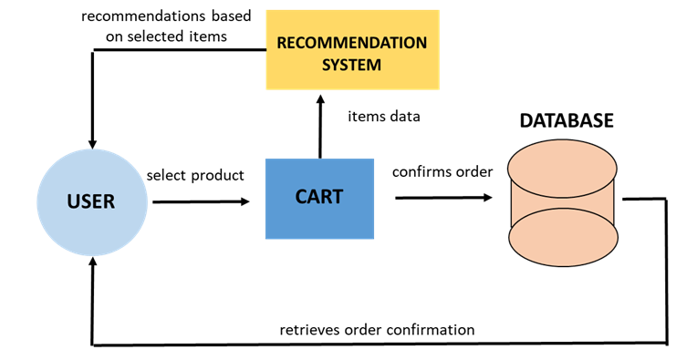

**Figure 6.1.** Data Flow Diagram (DFD)

**6.2. Activity Diagram**

An **Activity Diagram** is a visual representation of workflows and processes in a system. It models the sequence of activities and actions performed by different entities or actors within the system, illustrating the flow of control from one activity to another. Activity diagrams are particularly useful for modeling the dynamic aspects of a system, such as user interactions, decision points, and parallel or sequential processes. They show the flow of activities from start to finish, including conditional branches, loops, and concurrency, providing insight into how various operations are executed and how they relate to each other. This diagram is commonly used to analyze the flow of activities in use cases, business processes, or system functionalities, and it helps in understanding complex workflows and optimizing process efficiency. The activity diagram is shown in **Figure 6.2**.

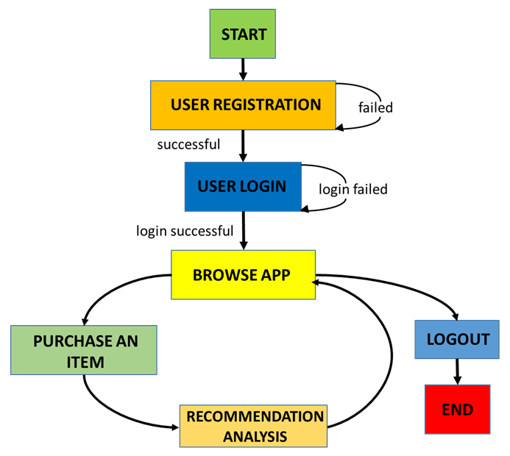

**Figure 6.2.** Activity Diagram

**6.3. Class Diagram**

A **Class Diagram** is a structural diagram used in object-oriented modeling to describe the static structure of a system. It shows the system’s classes, their attributes, methods, and the relationships between them. Each class represents a blueprint for creating objects and encapsulates data and behavior that are common to that type of object. The diagram highlights key concepts such as inheritance (where one class inherits properties and behaviors from another), association (the relationship between classes), and aggregation/composition (part-whole relationships). The Class Diagram is an essential tool in the design phase of software development, as it helps developers visualize the system's structure, identify potential issues in the system's architecture, and understand how different components interact and collaborate within the system. It plays a crucial role in object-oriented design and serves as a foundation for implementing the system’s functionality. The class diagram is shown in **Figure 6.3**.

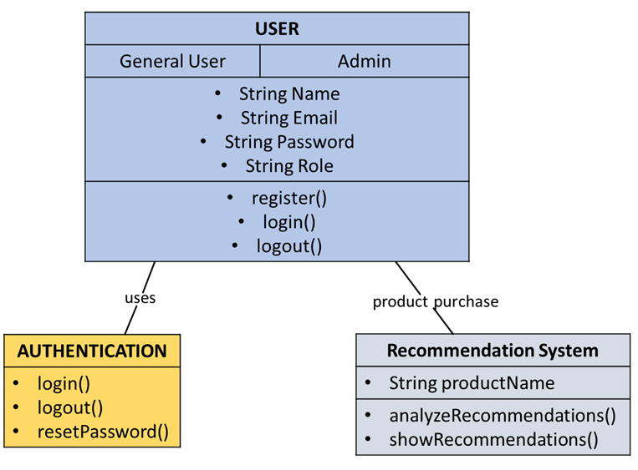

**Figure 6.3.** Class Diagram

**6.4. Snapshots of the project**

The images presented below provide a visual representation of various key pages and features of the AI-Driven E-Commerce application. Each image highlights an important aspect of the platform, showcasing its user-friendly interface and core functionalities.

**Homepage:** The homepage image displays the main landing page of the application, featuring a clean and welcoming layout designed to give users easy access to the platform's features, including symptom input and doctor recommendations.

**Login Page:** The login page image illustrates the interface where both patients and doctors can securely log into the system using their credentials. It is designed with user convenience in mind, ensuring a seamless authentication process.

**Signup Page:** The signup page image provides an overview of the user registration process. It captures the input fields for user details, including the necessary information for creating a new account, with a focus on simplicity and ease of use.

**Profile Page:** The profile page image showcases the personalized user dashboard where patients and doctors can manage their account settings, view past predictions, and update their personal information.

**About Page:** The about page image provides an overview of the project's purpose, offering insights into how the platform works and the technologies behind it, helping users understand the value proposition of "CareConnect."

**GitHub Repository:** The GitHub repository page image highlights the project's open-source repository. It includes the source code, documentation, and relevant resources for developers interested in exploring or contributing to the project.

**Symptom Analysis Page:** The symptom analysis page image illustrates the interface where patients input their symptoms. This page is crucial for processing user inputs through the AI model for disease prediction and diagnosis.

**Predicted Output:** The predicted output page image shows the result after the AI model analyzes the symptoms. It displays the disease prediction and includes additional information such as the severity of the condition and recommended next steps.

**Treatment History:** The treatment history page image illustrates how patients can view and store their past predictions and treatment records. This feature is designed for users to track their health over time and access historical medical data when consulting doctors.

**Available Doctors:** The available doctors page image provides a list of doctors, including their specializations, contact details, and availability. This feature assists patients in finding the right medical professionals based on their disease predictions.

**AI Metrics:** The AI metrics page image offers a visual representation of the performance metrics of the machine learning models used for disease prediction. It includes key metrics such as accuracy, precision, recall, and F1 score, reflecting the system’s predictive capabilities.

These images collectively demonstrate the user interface and functional flow of the AI-Driven E-Commerce application, as shown in **Figure 6.4-6.16**.

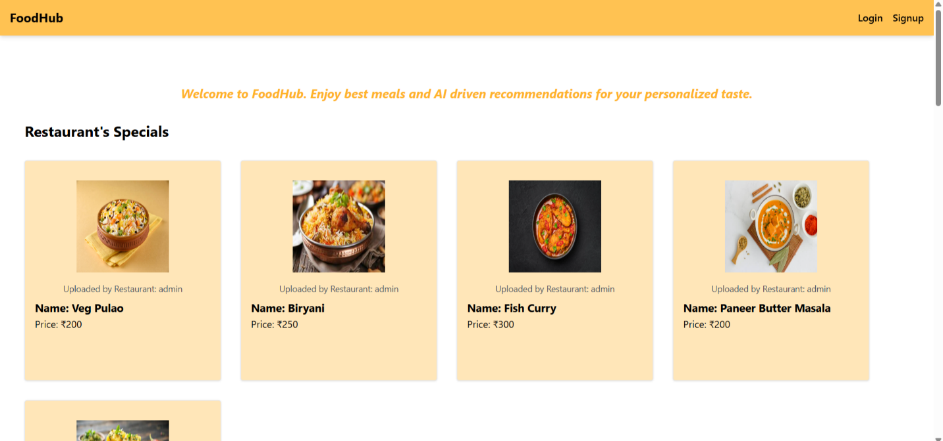

**Figure 6.4.** Homepage

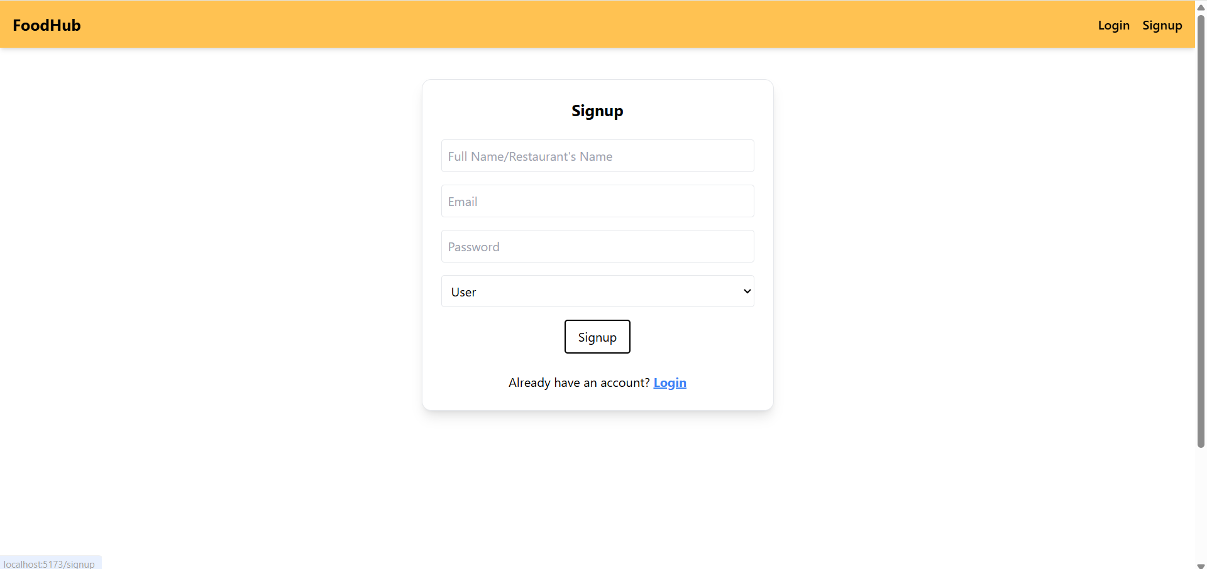

**Figure 6.5.** Signup Page

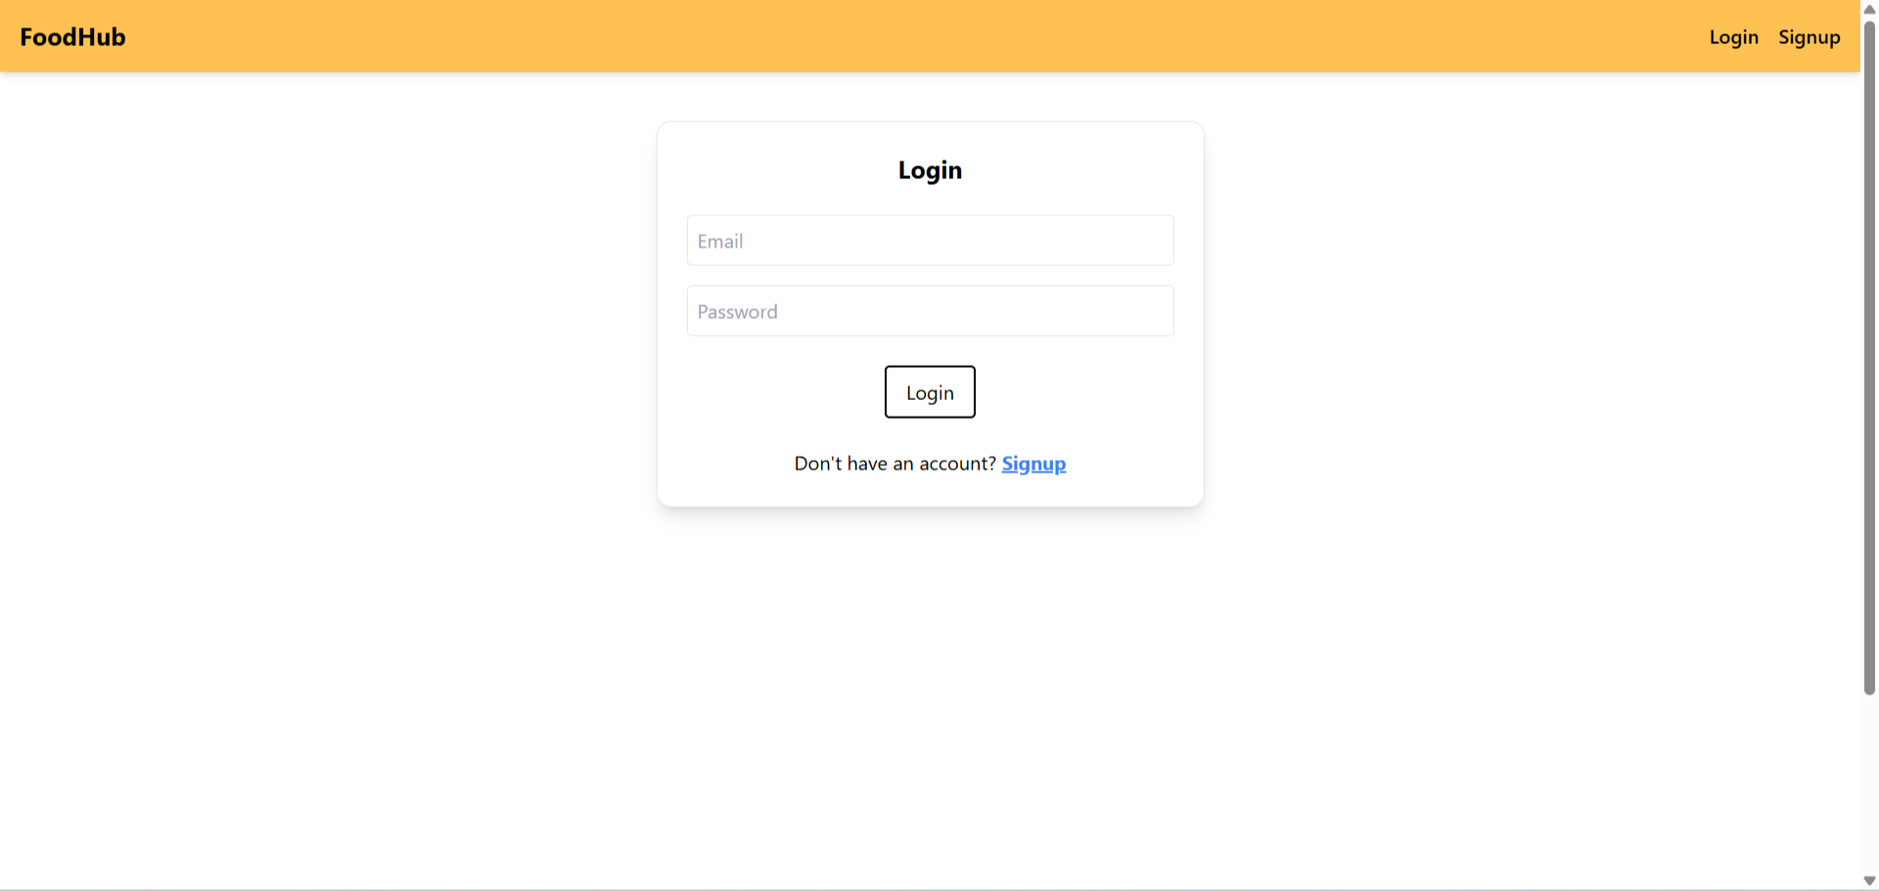

**Figure 6.6.** Login Page

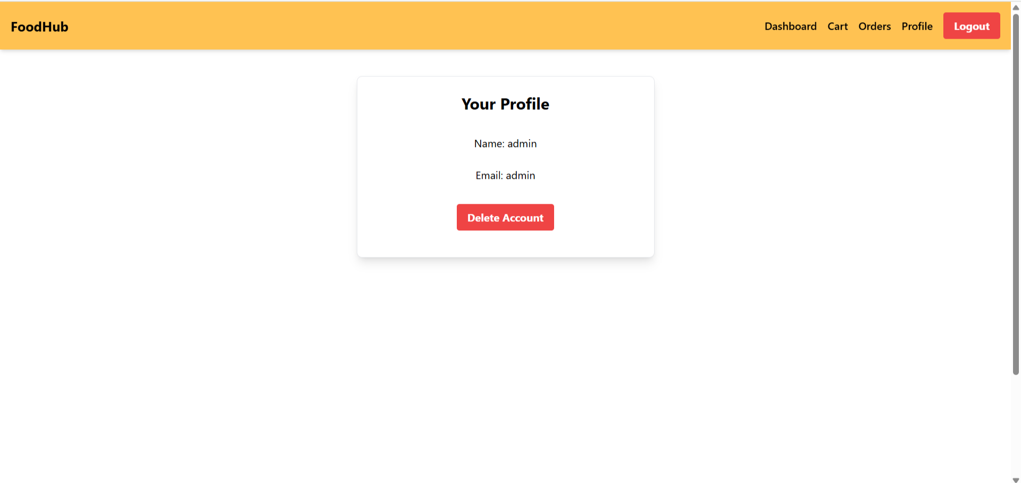

**Figure 6.7.** Profile Page: Admin

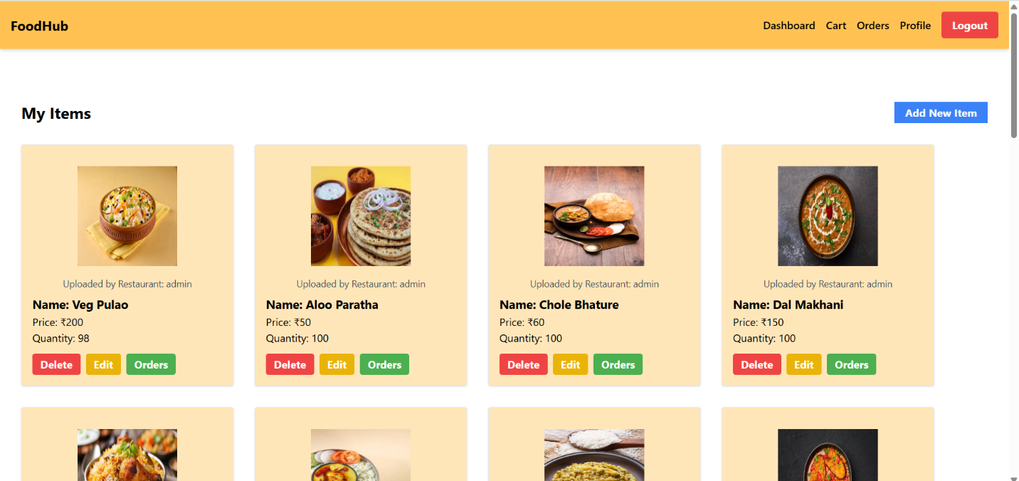

**Figure 6.8.** Admin Dashboard

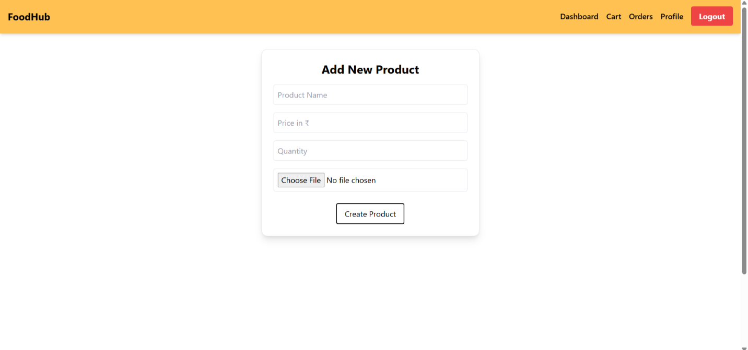

**Figure 6.9.** Add Product Page

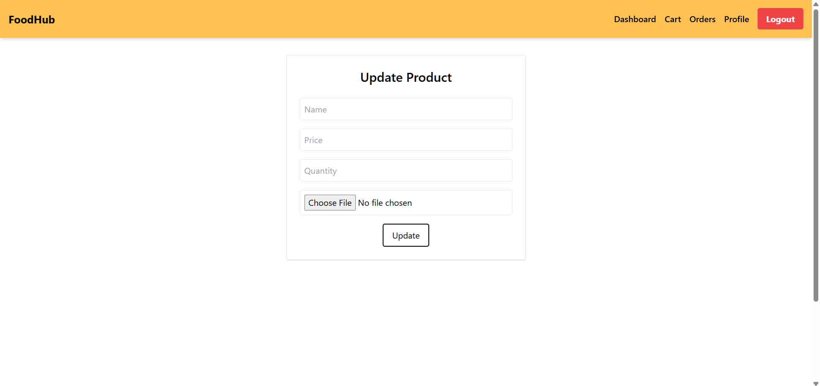

**Figure 6.10.** Update Product Page

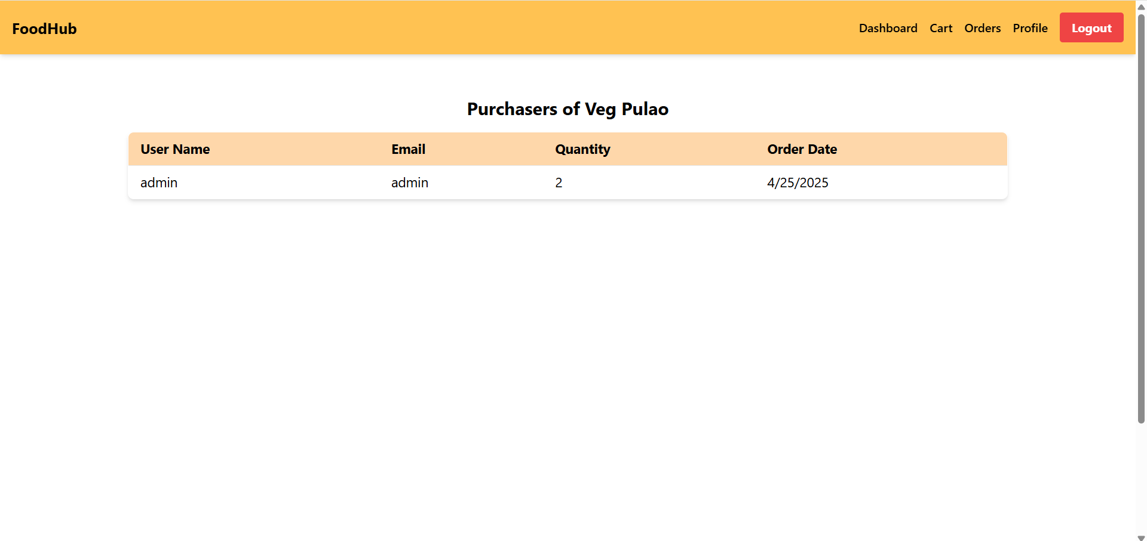

**Figure 6.11.** Product Purchasers

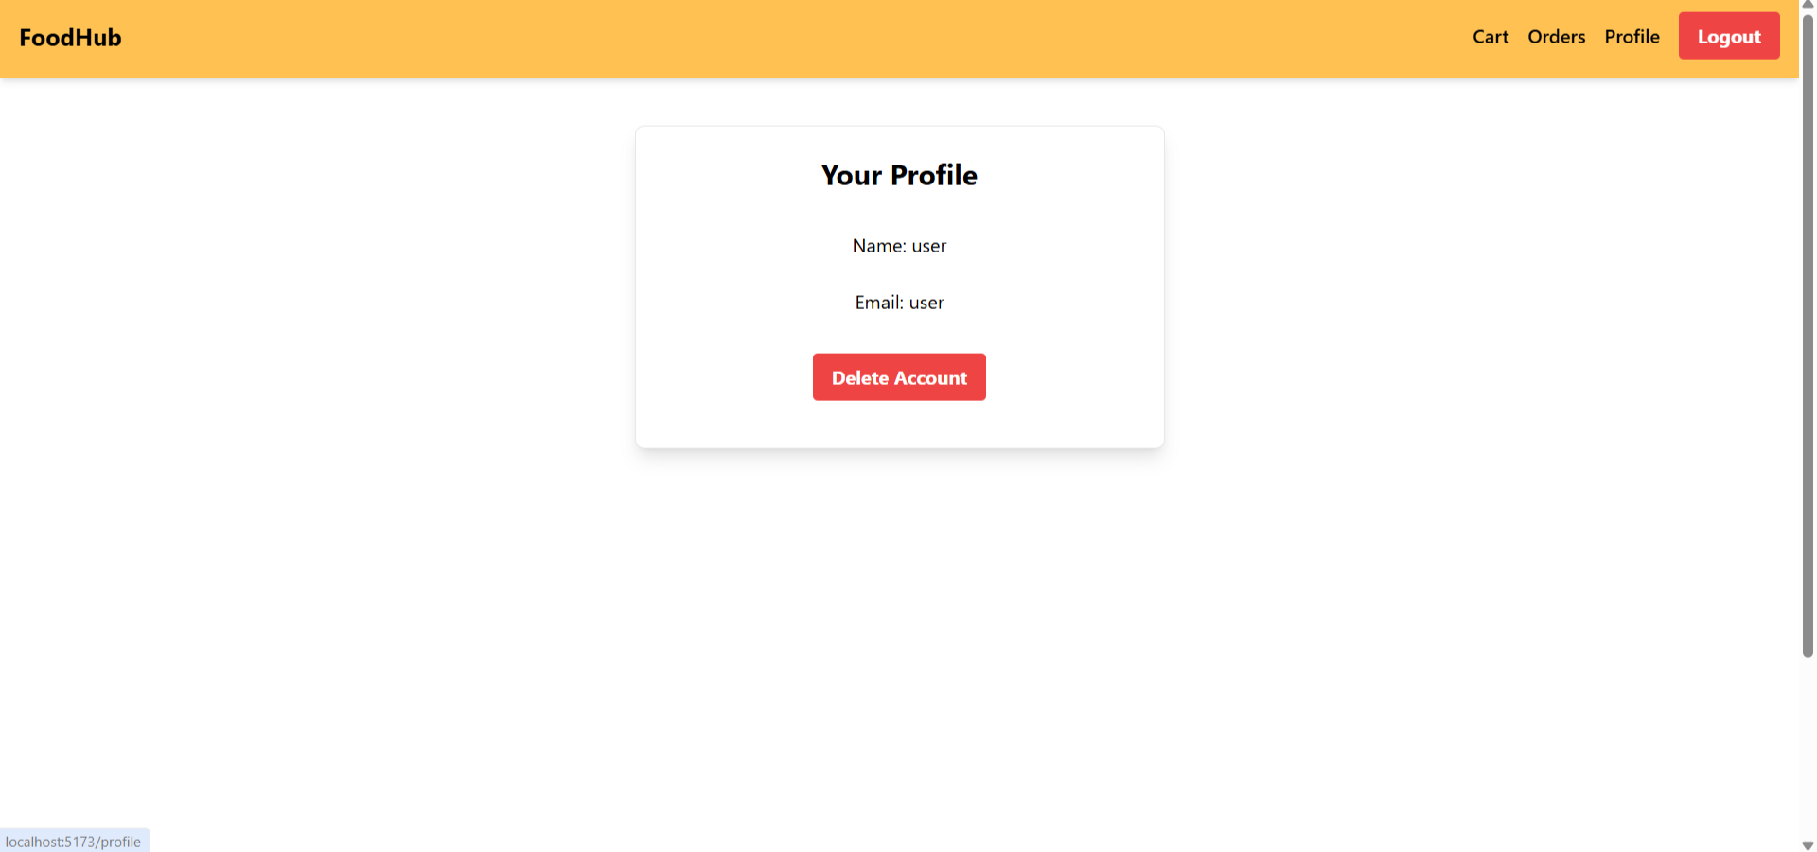

**Figure 6.12.** Profile Page: User

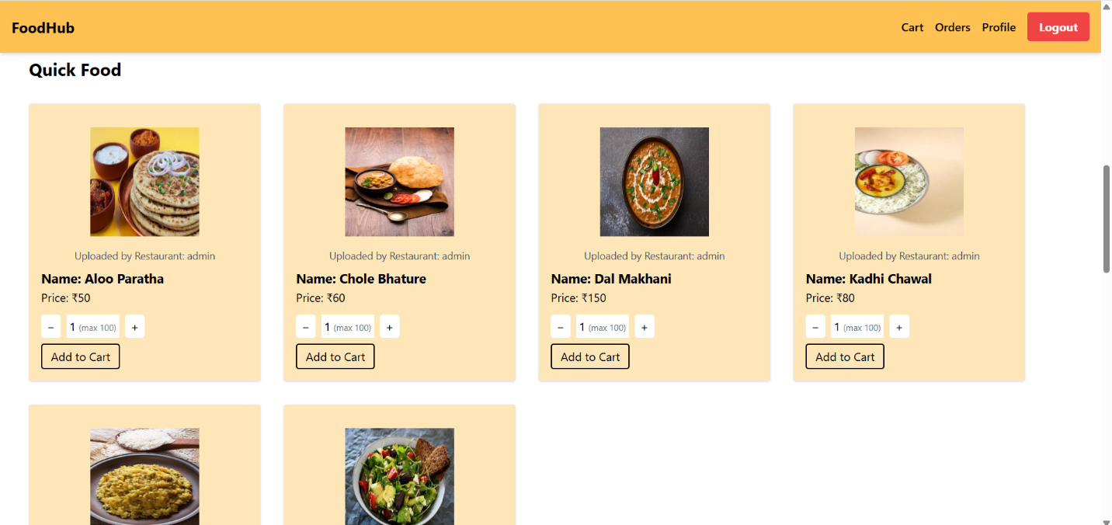

**Figure 6.13.** Products Section

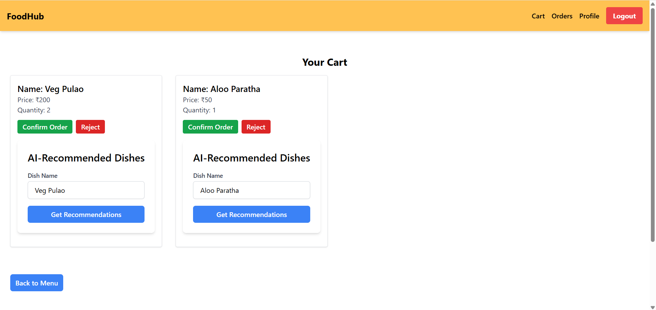

**Figure 6.14.** Cart

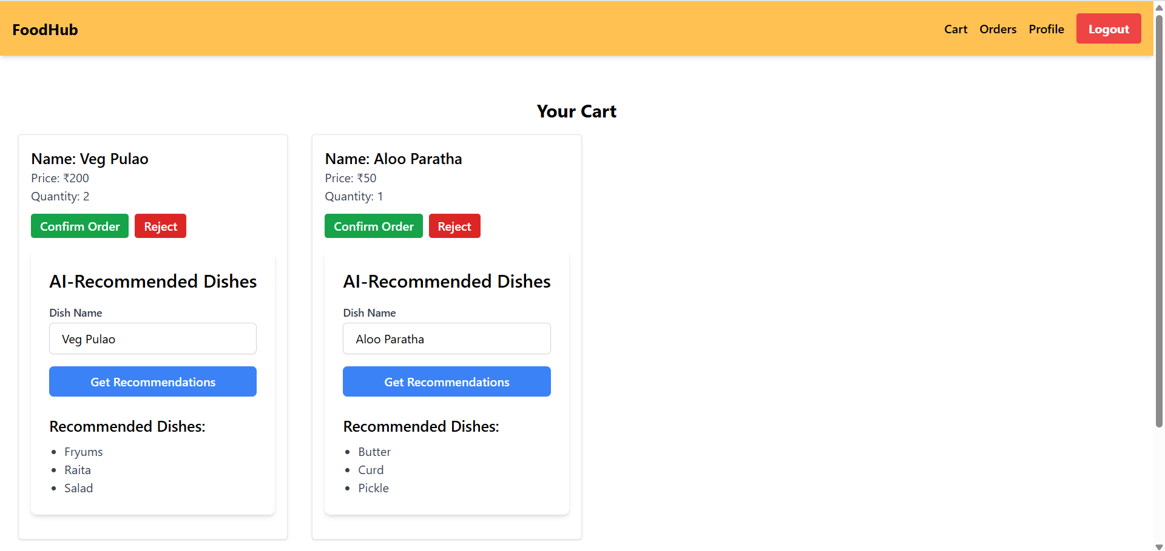

**Figure 6.15.** AI-Driven Recommendations

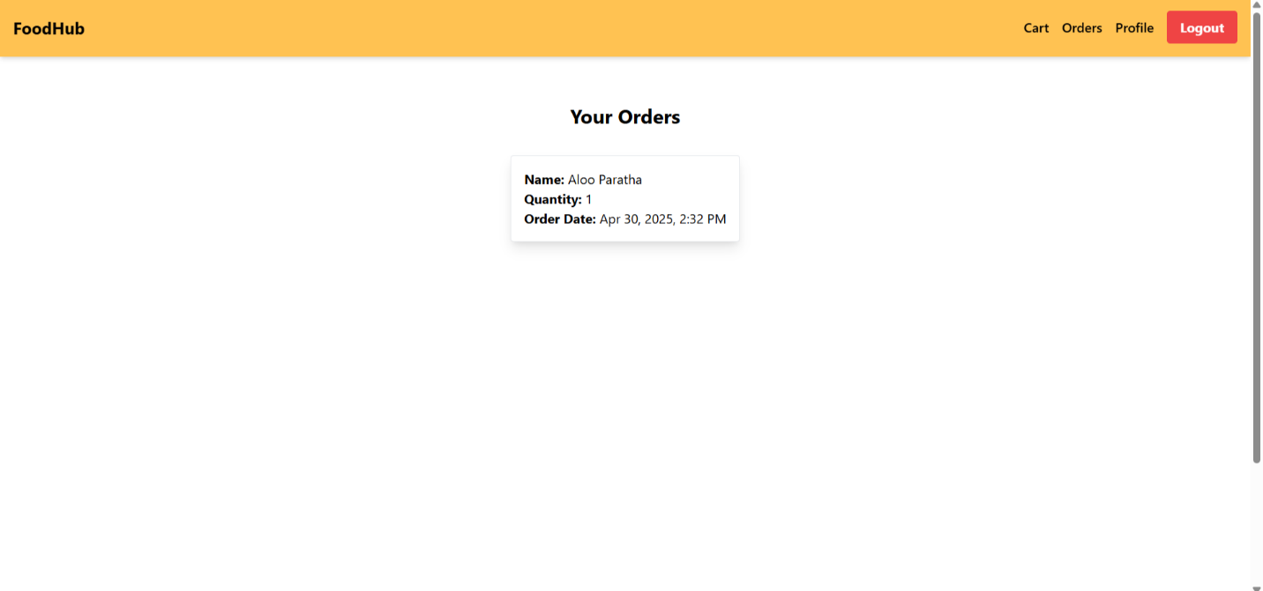

**Figure 6.16.** Order History

**CHAPTER 7.**

**CONCLUSION AND FUTURE WORK**

The AI-Driven Personalized Content Recommendation System for E-Commerce Web Applications is a groundbreaking solution designed to transform the shopping experience by utilizing artificial intelligence to optimize and personalize the user journey. In today’s increasingly digital world, where customer expectations are continually evolving, e-commerce platforms must adapt to offer highly tailored experiences. This system leverages advanced machine learning algorithms to analyze user behavior, interactions, and preferences, providing personalized product recommendations that drive engagement, increase sales, and enhance user satisfaction.

At its foundation, the project utilizes the MERN stack (MongoDB, Express.js, React.js, Node.js) alongside Flask, pandas, mlxtend, and joblib for its machine learning capabilities, ensuring a scalable, robust, and efficient platform. Tailwind CSS is employed for building a visually appealing and responsive user interface, enhancing the user experience across various devices. The heart of the system lies in its recommendation engine, which combines collaborative filtering, content-based filtering, and user interactions to suggest products that a user is most likely to buy. This predictive capability not only improves the shopping experience but also optimizes the chances of conversion by presenting users with the most relevant items.

The system goes beyond the traditional e-commerce model by intelligently analyzing user preferences and offering personalized recommendations in real time. By showcasing only the most relevant products, it reduces browsing time and enhances the likelihood of purchases. In addition, the platform offers a highly intuitive admin dashboard and user interface that allows both administrators and customers to manage profiles, view personalized suggestions, track past orders, and seamlessly navigate through the system. The combination of these features makes the platform easy to use for both technical and non-technical users, ensuring smooth interactions and quick decision-making.

With the integration of AI-powered technology and a comprehensive tech stack, this recommendation system equips e-commerce platforms to enhance user engagement, optimize sales strategies, and deliver highly customized experiences. As more businesses recognize the significance of providing personalized shopping experiences, this solution positions itself as an indispensable tool for e-commerce platforms looking to stay competitive in the dynamic and ever-evolving digital marketplace. The ability to engage users on a deeper, more personalized level is set to reshape how online stores interact with customers, marking a transformative shift in e-commerce business models.

The AI-Driven Personalized Content Recommendation System for E-Commerce Web Applications stands as a pioneering effort aimed at reimagining how e-commerce platforms can cater to their users through tailored, intelligent recommendations. In a market where customer satisfaction and personalized experiences drive business success, this system leverages powerful artificial intelligence to deliver exactly what users want, at the right time. By analyzing user behavior, past interactions, and specific preferences, it suggests products that are most likely to resonate with individual customers, thus increasing conversion rates, fostering greater customer engagement, and boosting overall sales performance.

The technical foundation of the project is built on a solid MERN stack (MongoDB, Express.js, React.js, Node.js) combined with Flask, pandas, mlxtend, and joblib for the machine learning model, ensuring that the platform is not only scalable but also efficient in handling large volumes of data. The use of Tailwind CSS helps create a responsive and modern user interface that ensures users have an enjoyable and intuitive browsing experience, regardless of the device they’re using. The recommendation engine at the core of the platform applies advanced collaborative filtering and content-based filtering techniques, alongside historical data, to suggest products that align with the user's specific tastes, preferences, and purchasing behaviors.

The system is designed to do more than just recommend products; it enhances the overall user journey. By analyzing user preferences, the platform tailors product suggestions, offers real-time updates, and empowers both admins and users with an easy-to-use interface. The integration of an admin dashboard allows for seamless management of user profiles, viewing past orders, and effectively managing the product catalog. For the end-user, the system ensures a more efficient and personalized shopping experience, where relevant products are displayed, helping them discover items they may not have found otherwise.

By combining cutting-edge machine learning techniques with a strong, reliable tech stack, this AI-driven recommendation system is poised to revolutionize the e-commerce landscape. As businesses increasingly prioritize customer-centric approaches, this system empowers e-commerce platforms to adapt quickly, optimize sales, and enhance customer satisfaction. With its ability to provide dynamic, personalized content in real time, this system is not only a valuable tool for increasing sales but also a game-changing innovation that can redefine how online retailers connect with and engage their customers. This powerful platform is ready to push e-commerce to new heights, helping businesses stay competitive in an ever-changing digital world.

While the AI-Driven Personalized Content Recommendation System for E-Commerce Web Applications is a highly effective solution, there is a wealth of potential for further development and enhancement. These future improvements would extend the functionality of the platform, improve user satisfaction, and cater to the evolving needs of both businesses and customers.

**Enhanced Personalization Algorithms:** Future versions could integrate deeper machine learning models such as deep learning-based recommendation systems, offering more accurate predictions by analyzing even more complex user behavior, contextual data (e.g., time of day), and user demographics.

**Integration with Social Media and Third-Party Data:** The system could leverage data from social media platforms and other external sources to better understand consumer preferences and behavior, providing even more personalized recommendations and potentially increasing the platform’s ability to target niche segments.

**AI-Based Price Optimization:** Machine learning algorithms could be used to dynamically adjust pricing based on various factors such as demand, inventory levels, customer behavior, competitor prices, and market trends. This could help businesses maximize revenue and enhance the competitive edge of their products.

**Augmented Reality (AR) Integration:** Incorporating AR capabilities would allow users to visualize products in their own environment before purchasing. For example, users could see how a piece of furniture looks in their living room or how a pair of shoes fits them virtually. This could increase conversion rates and provide a more engaging shopping experience.

**Multi-Platform Integration:** The platform could be expanded to integrate with additional e-commerce solutions, such as integrating product recommendations into third-party platforms like Shopify, WooCommerce, or Magento. This would enable e-commerce businesses to leverage personalized recommendations across multiple sales channels seamlessly.

**Mobile App Development:** A mobile version of the platform could be developed to provide customers with personalized recommendations on the go. This mobile app could include push notifications for recommended products, special discounts, and promotions based on user preferences and past behavior.

**Real-Time Dynamic Recommendations:** As user preferences evolve, the system could use real-time data processing to provide on-the-fly product recommendations during user interactions, adapting dynamically to factors such as browsing behavior, time spent on product pages, and product searches.

**Voice Assistant Integration:** With the rise of voice search, integrating the recommendation engine with voice-activated assistants (e.g., Amazon Alexa, Google Assistant) could provide an innovative and hands-free shopping experience for users.

**Support for Multi-Currency and Multi-Language:** To cater to a global audience, the system could offer multi-currency and multi-language support, allowing users from different regions to interact with the platform in their preferred language and currency.

**Customer Segmentation and Targeted Marketing:** By leveraging AI-driven customer segmentation models, the system could classify users into distinct groups based on their behavior, demographics, and preferences. This would allow for more targeted marketing campaigns, personalized offers, and tailored discounts, further enhancing the customer experience and driving sales.

**Advanced Analytics and Insights:** Future versions could include more advanced data visualization tools and business intelligence (BI) dashboards that offer in-depth insights into customer behavior, product performance, and sales trends. These insights would enable businesses to make informed, data-driven decisions.

**Sustainability and Ethical Consumption:** As sustainability becomes a growing concern for consumers, future versions of the system could integrate eco-friendly or ethical product suggestions, helping users make more responsible purchasing decisions.

**References**

[1] Bawack, R.E., Wamba, S.F., Carillo, K.D.A. et al. Artificial intelligence in E-Commerce: a bibliometric study and literature review. Electron Markets 32, 297–338 (2022). <https://doi.org/10.1007/s12525-022-00537-z>

[2] Srivastava, A. (2021). The application & impact of Artificial Intelligence (AI) on E-commerce. In Edited Book Volume 1, Issue 1 (pp. 171–175). ISBN 978-93-83569-10-6. Retrieved from <https://www.researchgate.net/publication/356635263>

**Team Details**

**Name:** Mohammad Vaish

**Roll Number:** 2000100548

**Contribution:** Frontend & AI Development

**Responsibilities:**

* Design and develop the user interface with HTML, CSS, and JavaScript. o Create interactive features like product lists and inventory dashboards.
* Ensure the front-end is responsive and easy to navigate.
* Collaborate with the back-end to display live data from the server.
* Developed ML model for recommendation.

**Name:** Adnan Sheikh

**Roll Number:** 2000100750B

**Contribution:** Backend & AI Development

**Responsibilities:**

* Set up and manage the database (MongoDB) for storing product and order data.
* Develop server-side logic to handle functions like inventory updates and order processing.
* Ensure secure data management and implement user authentication. o Integrate back-end with front-end for smooth data flow and real-time updates.
* Handle machine learning integration to frontend using flask.